1. Within-dataset

|  |  |  |  |
| --- | --- | --- | --- |
|  | English | Chinese | Turkish |
| Precision | 59% | 11% | 68% |
| Recall | 57% | 27% | 63% |
| F-score | 52% | 16% | 58% |
| Accuracy | 57% | 27% | 63% |

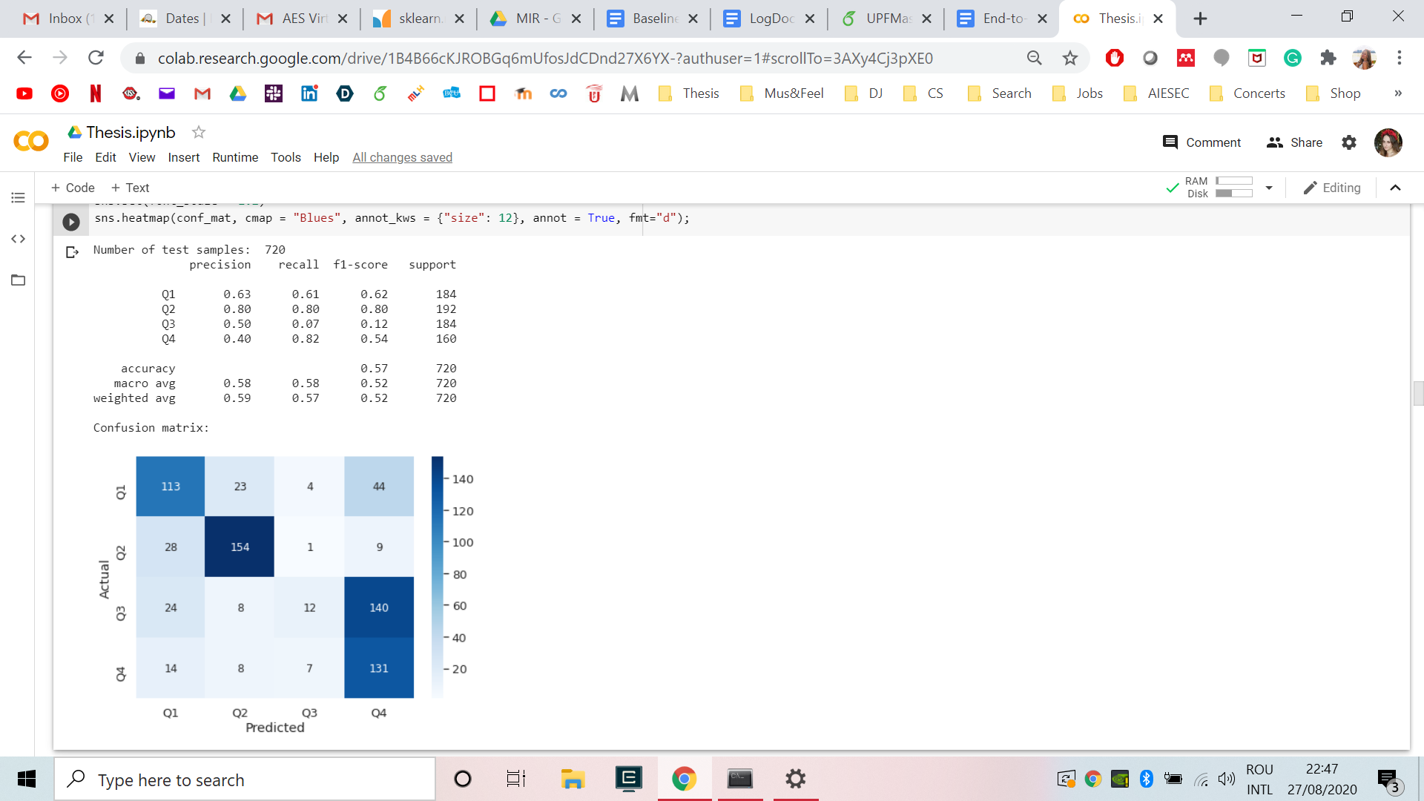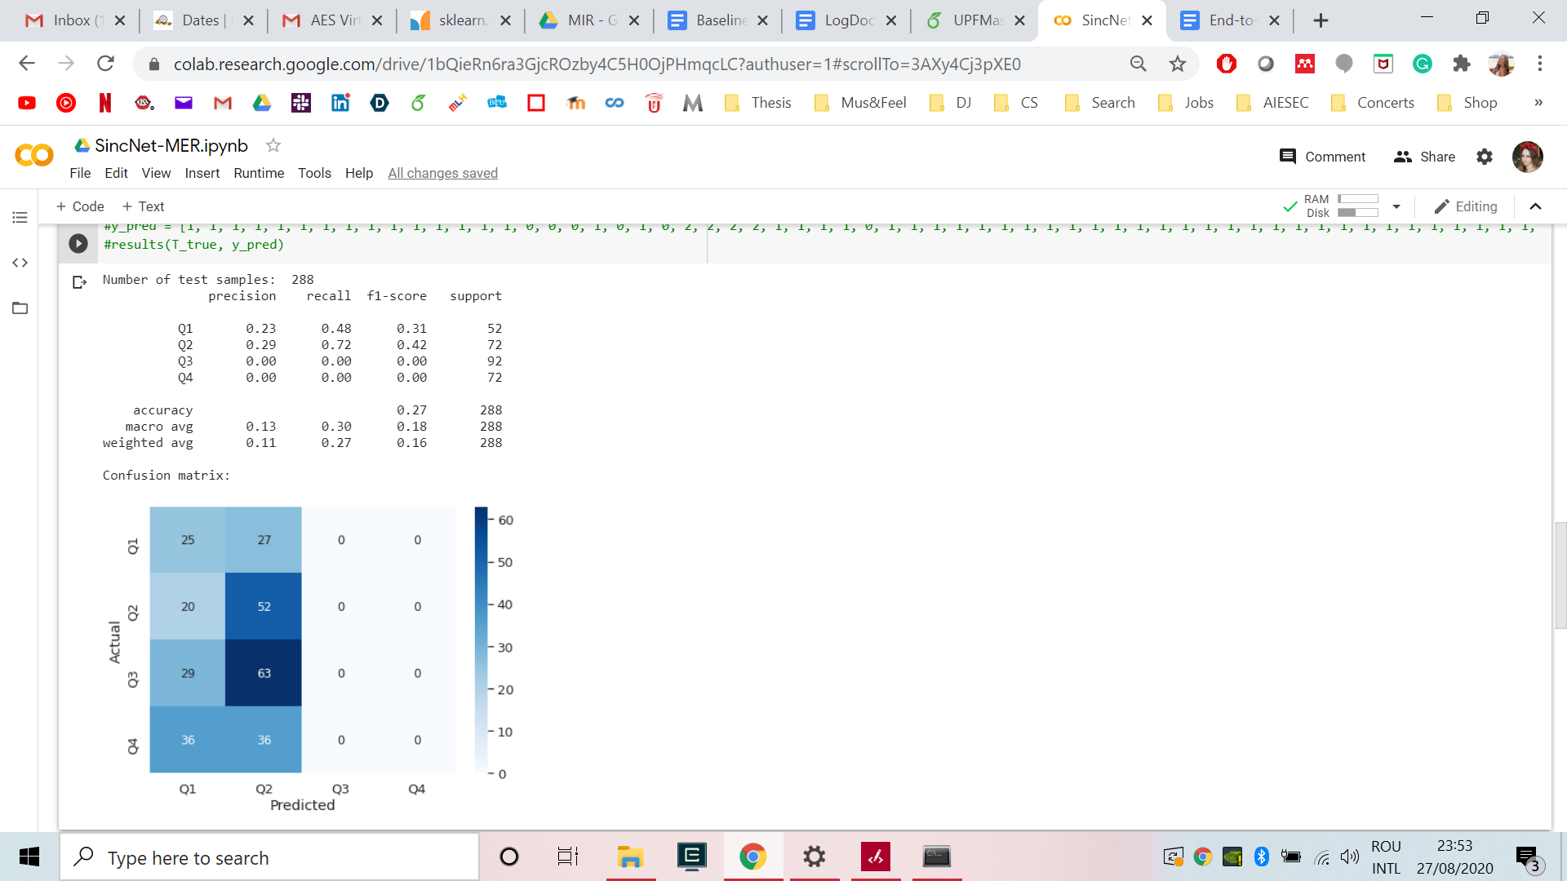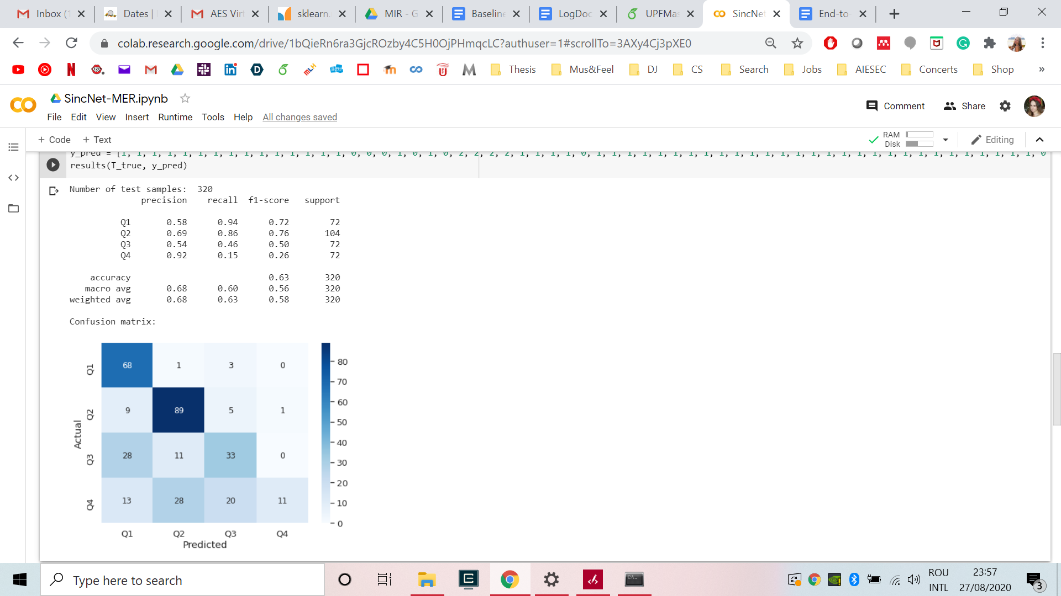

1. Cross-dataset

|  |  |  |  |  |  |  |  |  |  |  |  |  |
| --- | --- | --- | --- | --- | --- | --- | --- | --- | --- | --- | --- | --- |
| Train\Test | English | | | | Chinese | | | | Turkish | | | |
| Score(%) | P | R | F | A | P | R | F | A | P | R | F | A |
| English | 59 | 57 | 52 | 57 | 14 | 20 | 14 | 20 | 57 | 46 | 41 | 46 |
| Chinese | 9 | 23 | 13 | 23 | 11 | 27 | 16 | 27 | 21 | 39 | 27 | 39 |
| Turkish | 48 | 41 | 38 | 41 | 24 | 24 | 24 | 24 | 68 | 63 | 58 | 63 |

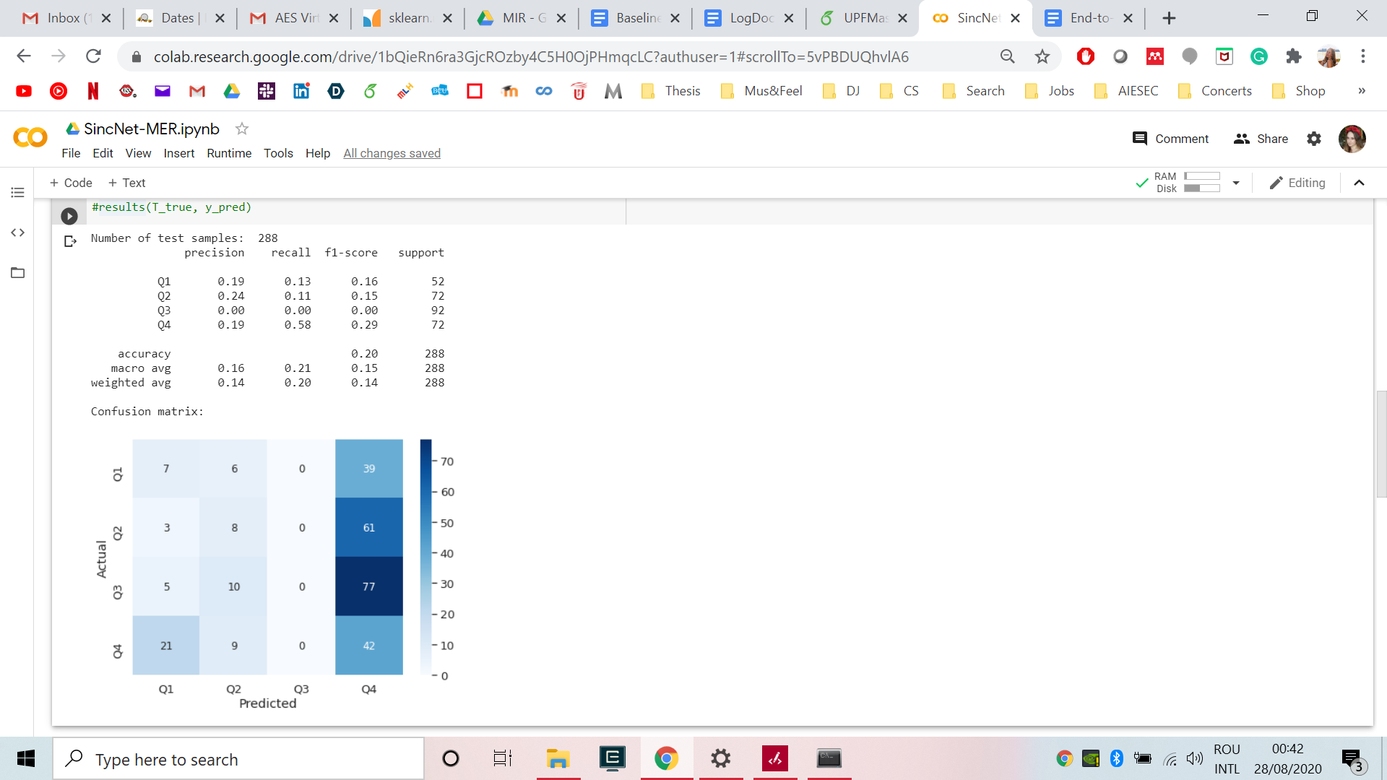 EN/CH 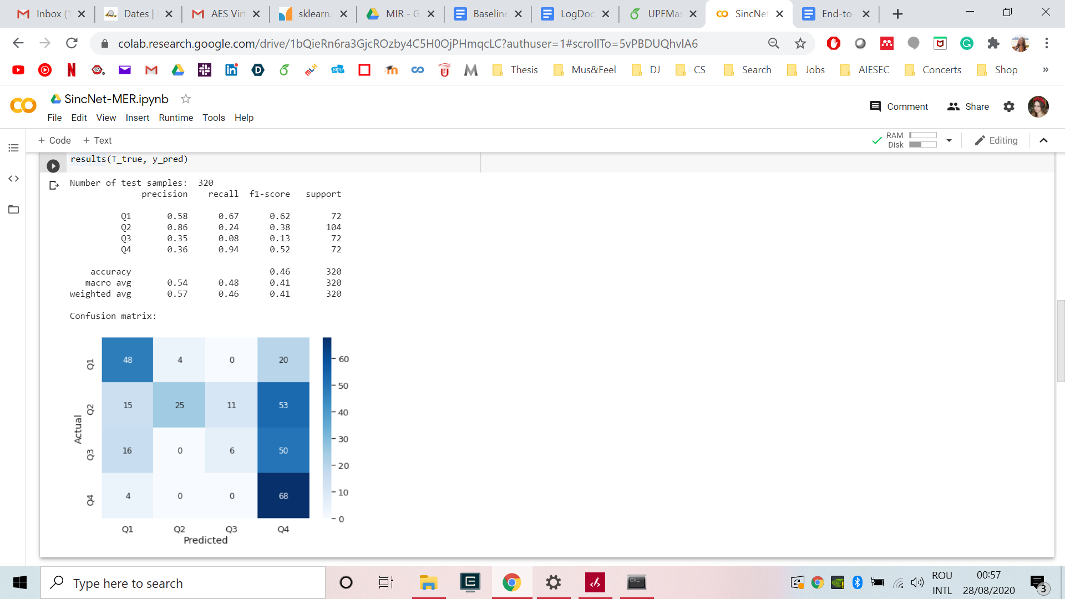 EN/TR

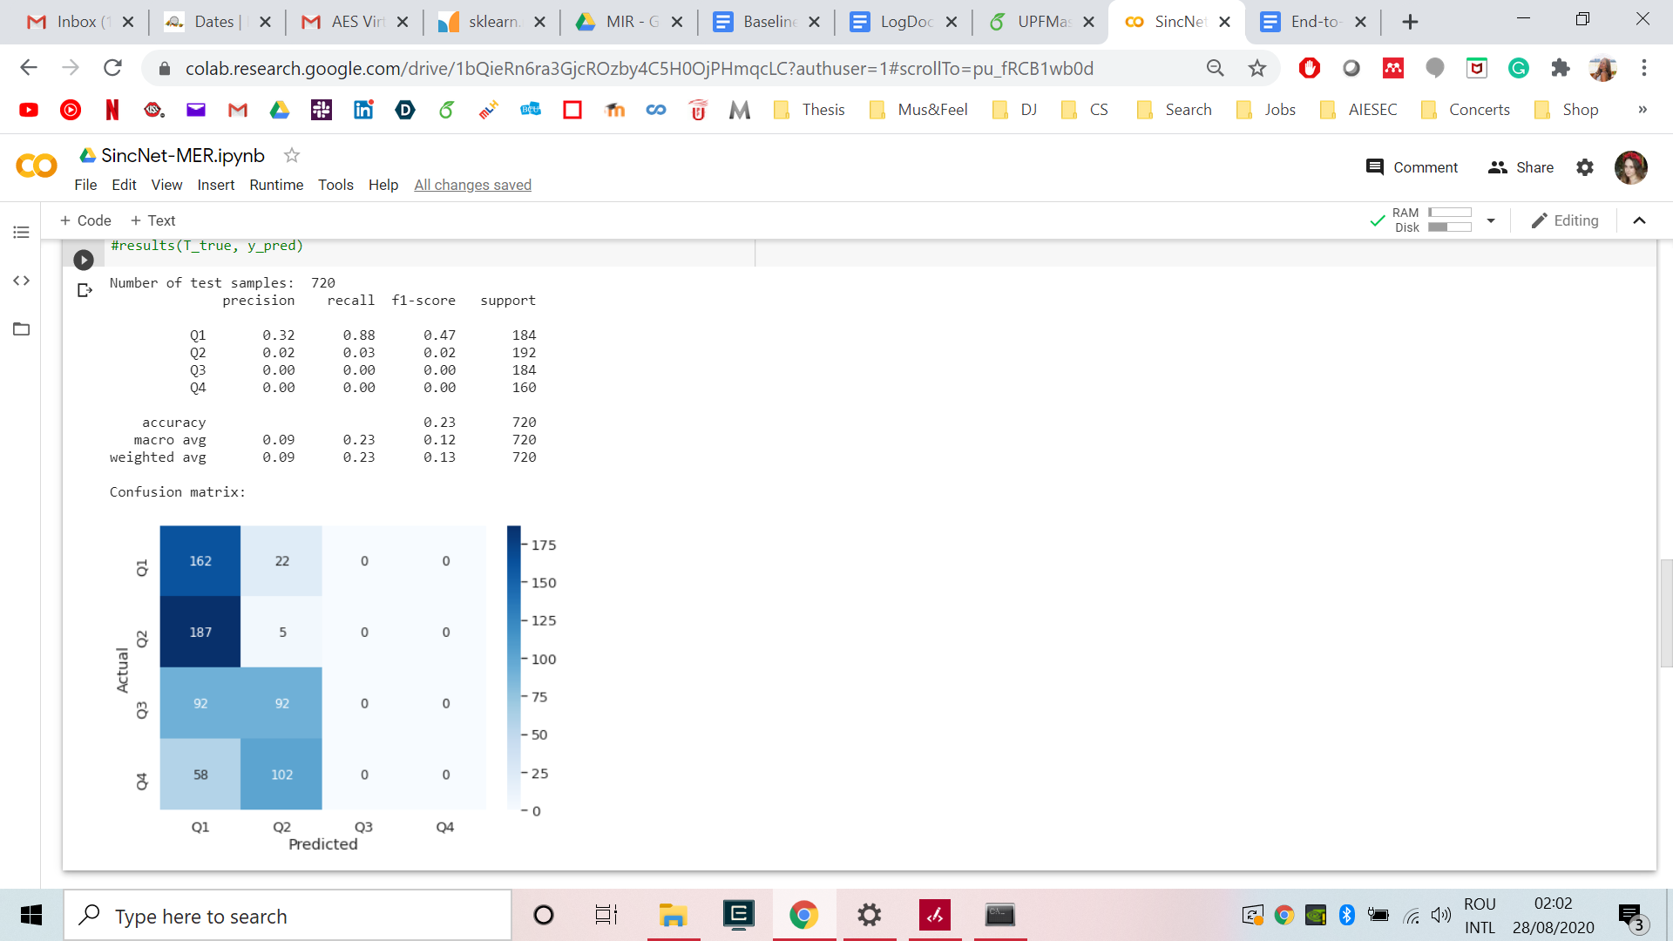 CH/EN 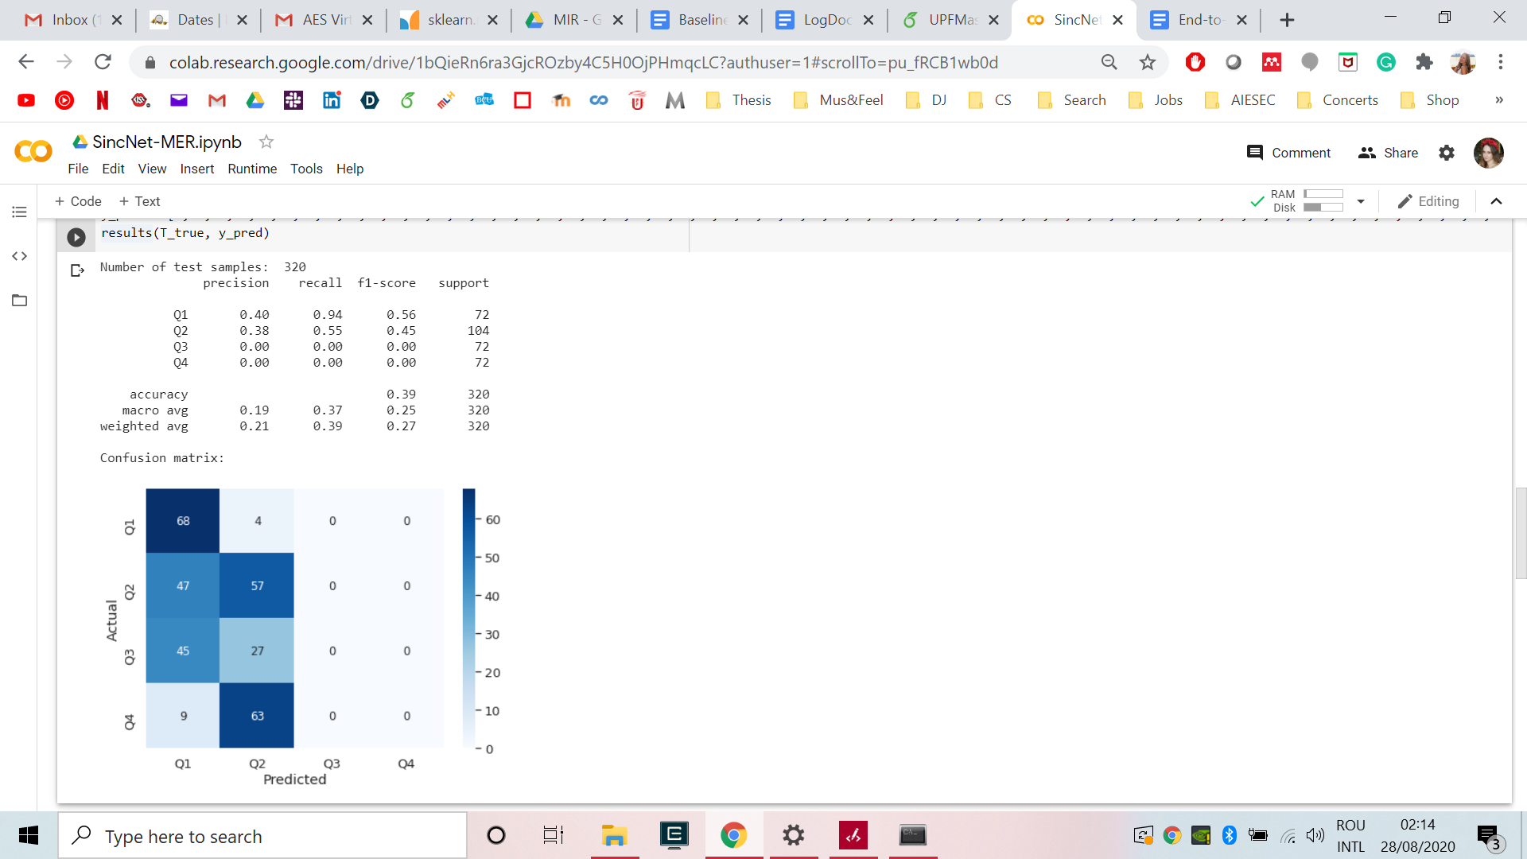 CH/TR

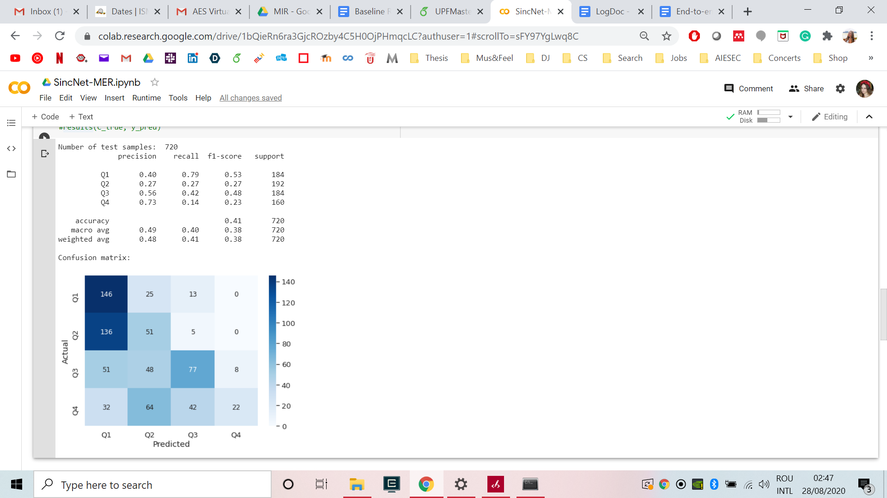 TR/EN 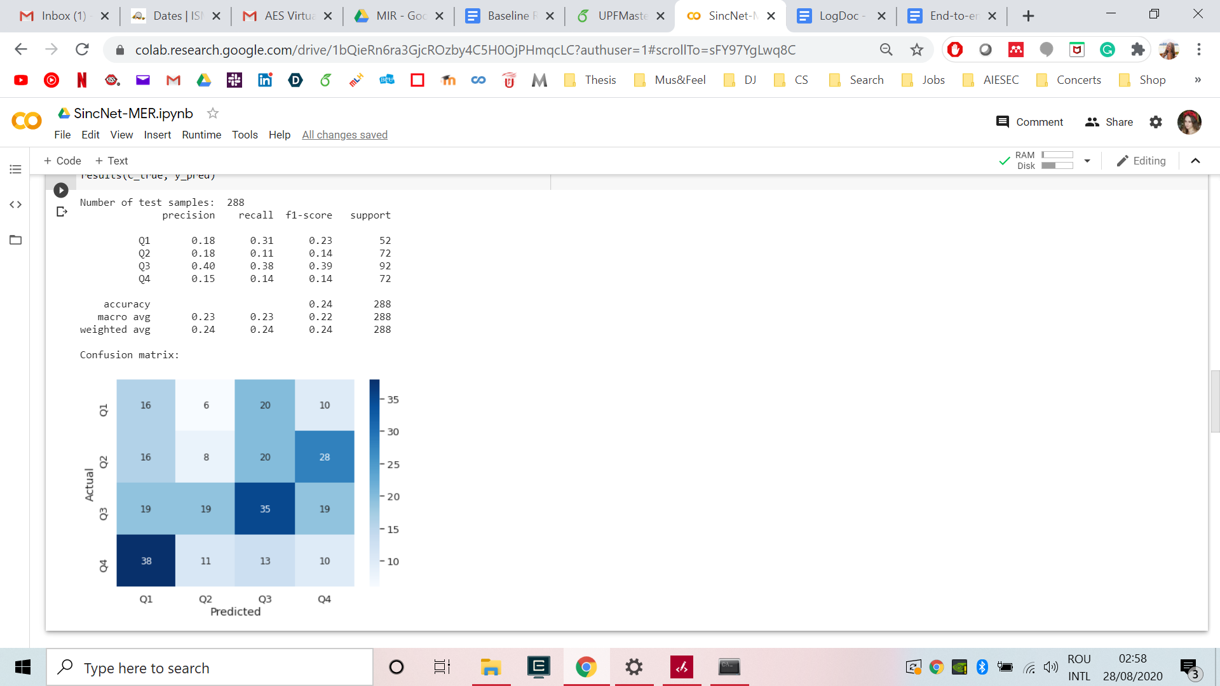 TR/CH

1. Mixed training

|  |  |  |  |
| --- | --- | --- | --- |
|  | English | Chinese | Turkish |
| Precision | 58% | 26% | 61% |
| Recall | 57% | 23% | 51% |
| F-score | 56% | 21% | 50% |
| Accuracy | 57% | 23% | 51% |

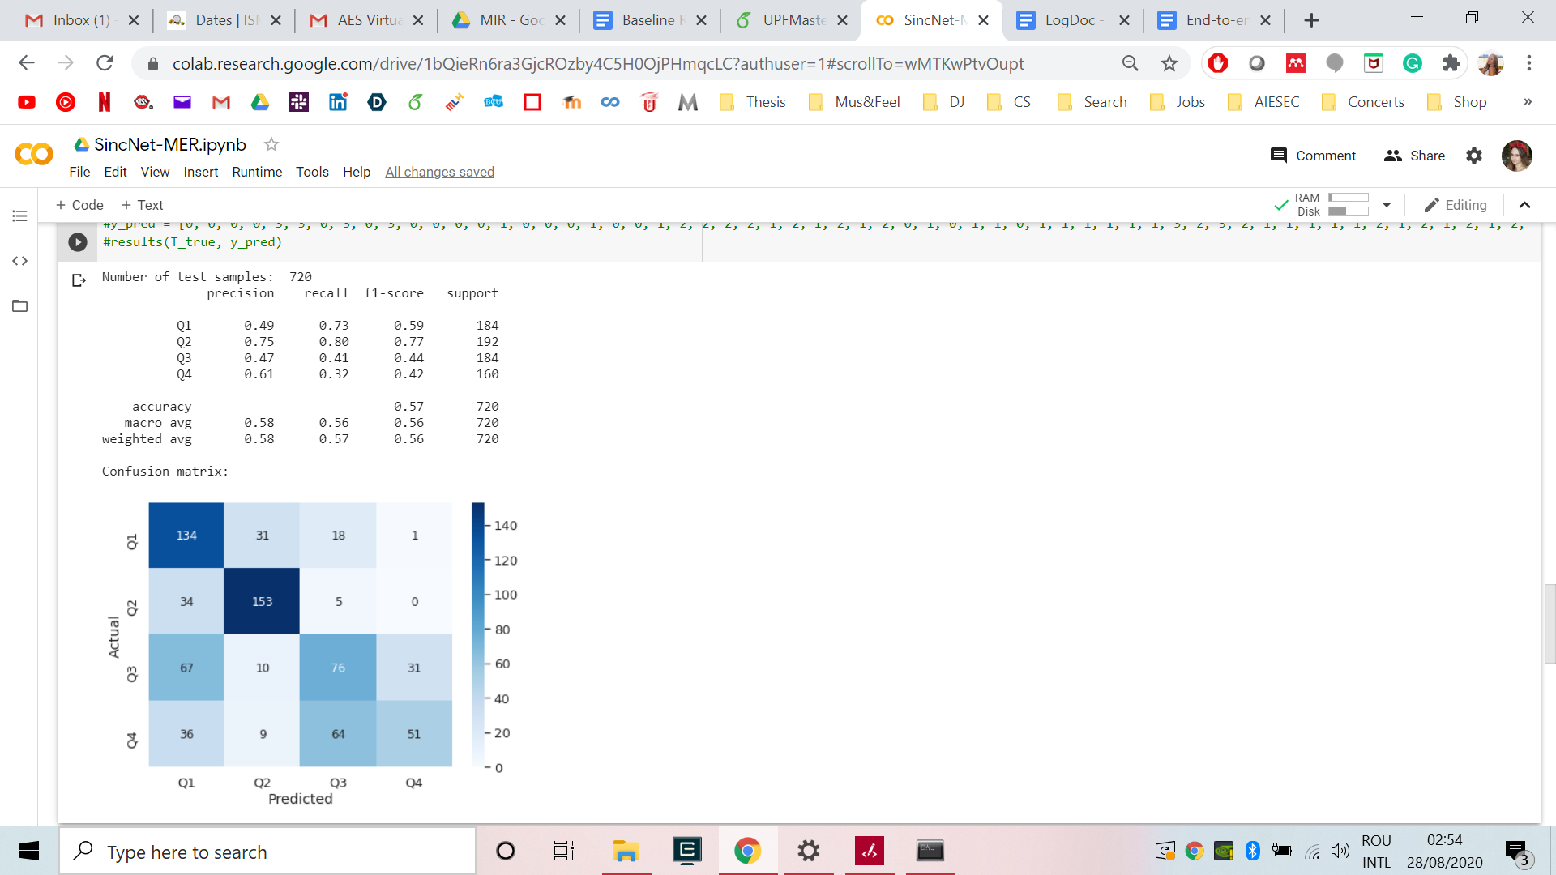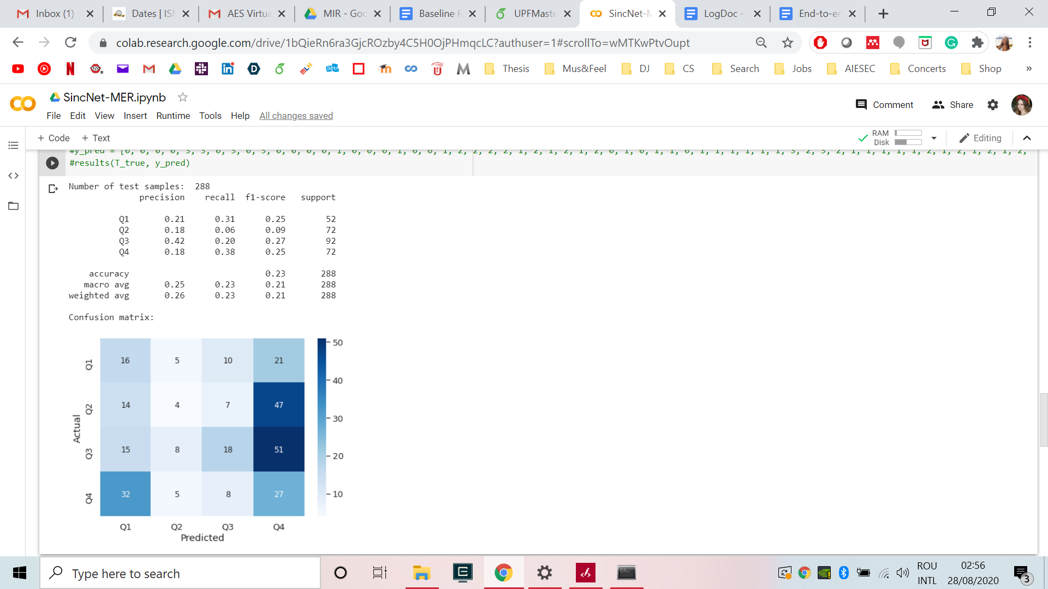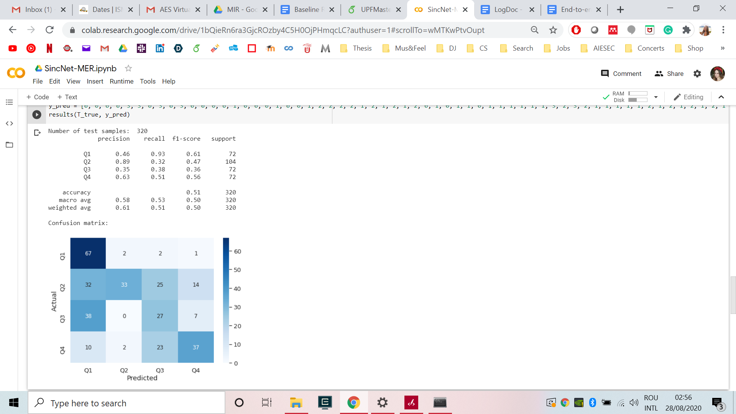

1. Transfer learning

|  |  |  |  |  |  |  |  |  |  |  |  |
| --- | --- | --- | --- | --- | --- | --- | --- | --- | --- | --- | --- |
| **Model** | | **Baseline: MLP** | | | | | **End-to-end: SincNet** | | | | |
| **Configuration** | **Data (train / test)** | **P** | **R** | **F** | **A** | **S** | **P** | **R** | **F** | **A** | **S** |
| **Within dataset** | **4Q / 4Q** | **65%** | **63%** | **62%** | **63%** | **720** | 59% | 57% | 52% | 57% | 720 |
| **TL 1 - finetune 4Q** | **CH-TR-4Q / 4Q** | - | - | - | - | - | 57% | 56% | 51% | 56% | 720 |
| **TL 2 - finetune 4Q** | **TR-CH-4Q / 4Q** | - | - | - | - | - | **61%** | **60%** | **57%** | **60%** | **720** |
| **Mixed dataset** | **ALL / 4Q** | 60% | 57% | 56% | 57% | 720 | 58% | 57% | 56% | 57% | 720 |
| **Within dataset** | **CH / CH** | **23%** | **30%** | **23%** | **30%** | **288** | 11% | 27% | 16% | 27% | 288 |
| **TL 1 - finetune CH** | **4Q-TR-CH / CH** | - | - | - | - | - | 10% | 24% | 12% | 24% | 288 |
| **TL 2 - finetune CH** | **TR-4Q-CH / CH** | - | - | - | - | - | 28% | 26% | 17% | 26% | 288 |
| **Mixed dataset** | **ALL / CH** | 22% | 23% | 22% | 23% | 288 | **26%** | **23%** | **21%** | **23%** | **288** |
| **Within dataset** | **TR / TR** | 74% | 71% | 71% | 71% | 320 | 68% | 63% | 58% | 63% | 320 |
| **TL 1 - finetune TR** | **4Q-CH-TR / TR** | - | - | - | - | - | **75%** | **75%** | **75%** | **75%** | 320 |
| **TL 2 - finetune TR** | **CH-4Q-TR / TR** | - | - | - | - | - | 72% | 71% | 71% | 71% | 320 |
| **Mixed dataset** | **ALL / TR** | 67% | 64% | 64% | 64% | 320 | 61% | 51% | 50% | 51% | 320 |